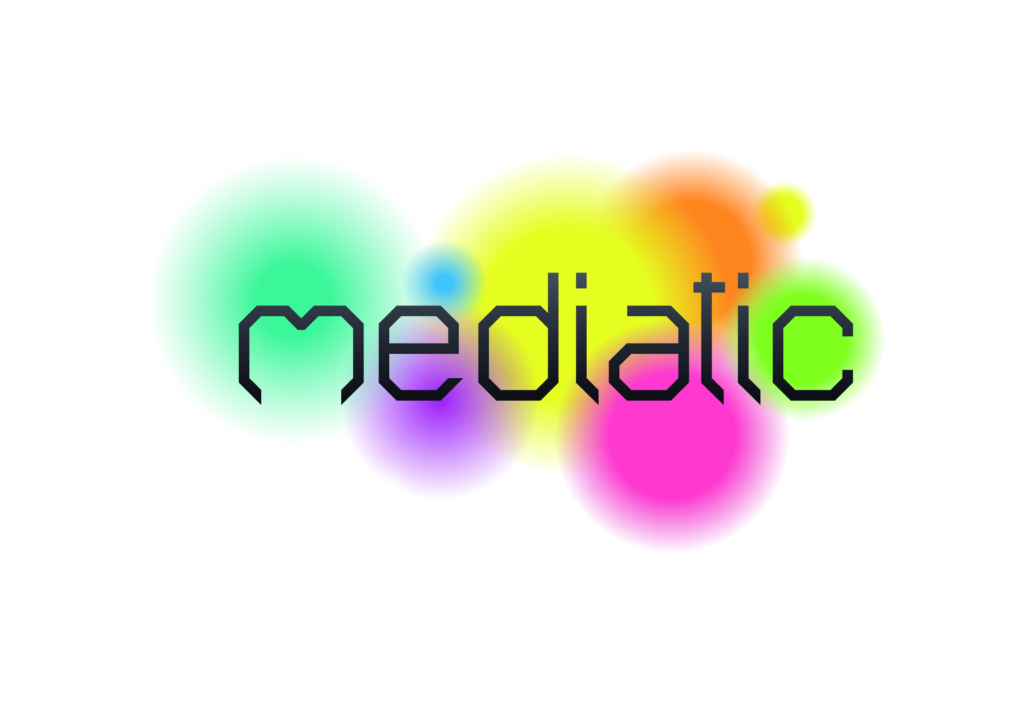

1.pielikums

Tehniskajai specifikācijai

„Ekspertu pakalpojumi projektā „Informācijas sabiedrības

un IKT attīstība audiovizuālajā uzņēmējdarbībā ” (MEDI@TIC)

Iepirkuma identifikācijas Nr. VPR/2012/__/MEDI@TIC

The guidelines for the

Policy Implementation Plan

General contents

The results generated shall offer a realistic and pragmatic diagnosis of the strengths, trends, weaknesses and opportunities for promoting ICTs in the audiovisual sector. On this basis, and taking into account the best practices identified (and any other available materials and local methodologies), the partners shall identify and select a series of policies, improvements and measures to be implemented at local, regional and, eventually, national levels.

At the meantime, the policies and measures to be drafted should include recommendations that will cover the 3 basic levels of policy development:

- Identification of target objectives,
- Legislative policies &
- Executive measures (actions).

In that sense, the policies could be classified and divided into 27 different sub-groups:

3 Objectives:
- Animation, Recreation & Digital effects (incl. videogames)
- Production of audio-visual contents for new distribution supports in the digital era (Internet, mobile technology, Digital TV, new digital supports, etc.)
- Inter-sectorial & Interregional co-operation, to promote cooperation among companies of digital contents (incl. Research & Technological centres, universities, etc.) and the audio-visual sectors (incl. Medias)

x 3 Target groups of policy-makers: 1) Local;
2) Regional;
3) National.
x
- 3 levels of policy development: 1) Identification of target political objectives;
2) Legislative policies
3) Executive measures

= 27 potential sub-groups to classify proposals.

Draft Index & Structure of the Policy Implementation Plans (Proposal)

- Introduction & Objectives
(about the project & document – approx. 2 pages)

- Methodology (approx. 2 pages)

- Diagnosis of the partner institution (between 20-30 pages, altogether, as follows)

  - Description of the sector (- between 10 – 15 pages).
Some questions that could be answered here could be as follows:
- A brief overview of existing audio-visual education & training in your country
- A description of the main distribution channels used in your country for audio-visual works, including any new digital channels (e.g., video on demand or catch-up TV, mobile technology)
- An overview of the law and regulations surrounding the audio-visual sector in your country, including any important, or particularly successful, measures or policies
- Any audio-visual sector clusters in your country or region?
- How is the market segmented in your country or region?
- An identification of key stakeholders in the audio-visual sector in your country or region
- Any particular business models – successful or unsuccessful – used in the audio-visual sector in your country or region?
- Any particularly good examples of technology employed?
- Any comments on the digitalisation or online exploitation of broadcasters’ archives?
- What makes the audio-visual sector unique in your country or region?
- What are the key problems in the audio-visual sector in your country or region?
- What innovative developments are in the pipeline in your country or region?
- Etc.

  - Existing institutional activities and capacities (between 5-10 pages)
- What are your key competences, activities, resources and difficulties around the promotion of ICT in the audiovisual sector (in general), and in particular on a) Animation, Recreation & Digital effects ; b) Production of audio-visual contents for new distribution supports in the digital era ; c) Inter-sectorial & Interregional co-operation, to promote cooperation among companies of digital contents.
- What other institutional actors/external resources are involved in such sector and should be taken into account.

  - SWOFT ANALYSIS ( +- 5 pages).

- Identification of Policies to be implemented (Fiches – as many and as long as needed)
  - Within your institution (at local or regional level)
  - In cooperation with other institutions (at local/regional/national level)
Example of fiche in the following page

- Summary of Policies (Table)
- Timescale – Summary of Implementation Planning (Table)
- Recommendations (+-2 pages)
- Conclusions (+-2 pages)

Example of potential contents of the Policy to be implemented Fiches

Level of policy development: □ Local □ Regional □ National

Kind of measure/Policy: □ Identification of target political objectives
□ Legislative policies
□ Executive measures

Affecting:
□ Animation, Recreation & Digital effects (incl. videogames)
□ Production of audio-visual contents for new distribution supports in the digital era
□ Inter-sectorial & Interregional co-operation, to promote cooperation among companies of digital contents (incl. Research & Technological centres, universities, etc.) and the audio-visual sectors (incl. Medias)
□ Others (i.e. audiovisual technologies applied to traditional industries)

Title of the Policy: XXXX
Objective:
Key tasks:
Action taken/planned – Methodology
Leading institution/department
Resources needed/used
Timescale
Evaluation measures

Of course, the partners should focus on their own level and competences, but it would be good to recommend/promote policies that shall be implemented by other institutions, at other levels.
Remember: we are talking about policies in order to improve ICT issues to the sector, not to solve all problems of the sector.

