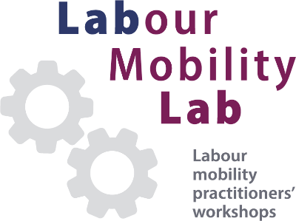
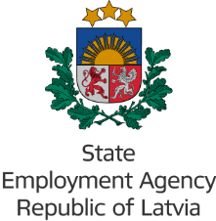
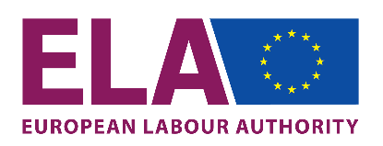

Mutual learning on return mobility
Focus: young professionals and youth in general

23-24 April 2026
Hotel Pullman, Jēkaba iela 24, Rīga, Latvia

Agenda
Day 1 – 23 April 2026
09.00 – 9.30 | Registration and welcome coffee
09.30 – 10.00 | Opening  - European Labour Authority, Iveta Labra, NLO Latvia  - Welcome from the Ministry of Welfare, Ingus Alliks, State, State Secretary  - Workshop objectives and expected outcomes, Patricija Kezele, Senior Labour Mobility Information Officer, ELA
10.00 – 11.00 | Setting the scene  - Updates since the Return Mobility Workshop in Jūrmala (Remigration coordinator Inga Madžule, NVA EURES project manager/coordinator, Līga Baufale)  - Overview of the return mobility landscape for young professionals and youth (Assoc.Prof. Baiba Bela, Senior Researcher, University of Latvia)  - Latvia's return mobility policy initiatives (M.Bilsēna, Ministry of Foreign Affairs) – 15 min  - Stories from returnees – Darja Necepurenko, Deivids Stasjulis
11.00 – 11.20 | Coffee break
11.20 – 13.00 | Group work  - Action points for reaching out to young professionals and youth  - Action points for improving information provision and support for young returnees  - Key initiatives for collaboration among relevant institutions and stakeholders
13.00 – 14.00 | Lunch
14.00 – 14.30 | Plenary discussion  - Sharing group findings
14.30 – 16.30 | Practices from Member States  Presentations and Q&A  - Croatia, Mladen Barać, State Secretary, Ministry of Demography and Immigration  - Ireland, Marcella Smyth, Ambassador of Ireland to Latvia  - Romania, Rareș Dinu, Community Manager of Repatriot  - Lithuania, Eglė Martinkėnienė and Agnė Skučaitė-Leonavicienė, PES
16.30 – 16.50 | ELA mapping of support instruments on return mobility  - Presentation (Patricija Kezele, Senior Labour Mobility Information Officer, ELA)
16.50 – 17.00 | Conclusions of the first day

Day 2 – 24 April 2026
08.45 – 9.00 | Welcome
09.00 – 09.50 | New information channel and support for returnees  - Presentation of the new Latvian website for returnees remigracija.lv,Vita Ziemele, Senior Expert, Ministry of Smart Administration and Regional Development  - ‘EURES support for young professionals’, Renāte Prēdele, EURES Adviser, State Employment Agency
 | Group work: case studies & peer review
09.50 – 11.30 | - Small group discussions on:  - Case studies for inspiration  - Peer review of website and/or other materials (test group exercise)  - Preparation of group findings
11.30 – 11.45 | Coffee break
11.45 – 12.45 | Plenary discussion  - Sharing group findings  - Open discussion on lessons learnt and improvement ideas
12.45 – 13.05 | Workshop conclusions  - Summary of outcomes  - Next steps and follow-up actions
13.05 – 13.15 | - Close of the workshop (Patricija Kezele, Senior Labour Mobility Information Officer, ELA)  - Closing remarks  - Satisfaction survey
13.30 – 15.00 Networking lunch

Language of the workshop: English, without interpretation, with Latvian-only and English-only breakout groups.

